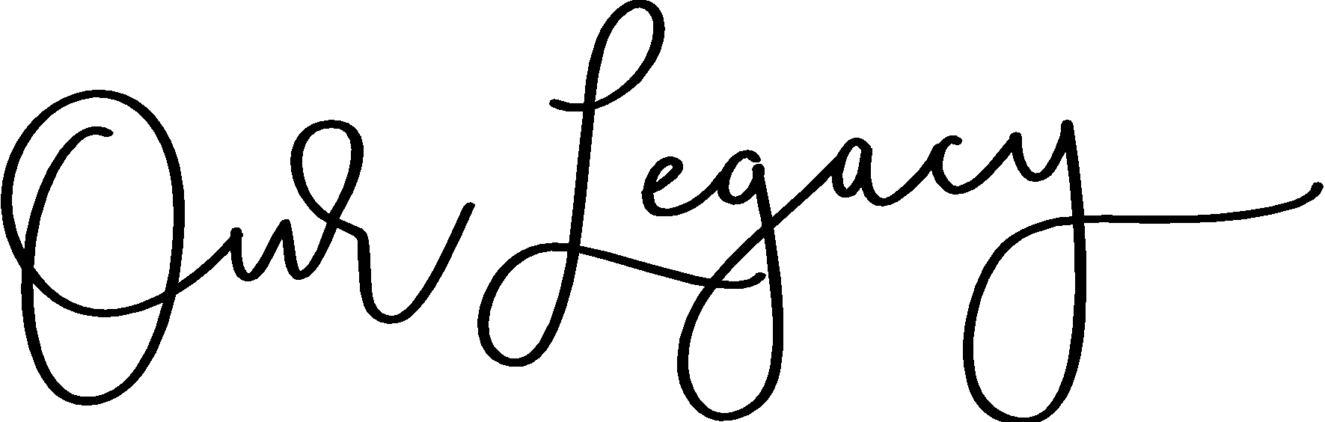  Researching the SMITH line that originated with CHARLES SMITH who immigrated from England in 1710 with his three sons: JACOB, JOHN, and WILLIAM [all three brothers and JACOB’s son PAUL, served in the Revolutionary War]. JACOB SMITH [4th GG] and son PAUL SMITH [3rd GG] and his family settled in Lebanon, then Blairstown, New Jersey. PAUL’s son ANDREW SMITH [2nd GG] served in the War of 1812 then moved to Toronto, Ontario with his wife ANNA HART, where they raised ANDREW SMITH Jr. [GG] and his 11 brothers and sisters. The SMITH descendants were brickmakers and community leaders in Ontario demonstrating intellect, leadership, and resourceful courage of their pioneer ancestors. A deeply religious family, the SMITHs worked for the good of God, their family, neighbors, and community. | Andrew Smith Jr |  |  |  |  | Penny Pringle
 | [1827 – 1903 | ] |  |  |  | [1843 – 1886]
 | Andrew Smith III. |  |  |  |  | Margaret Cole
 | [1873– 1947 | ] |  |  |  | [1885 – 1954]
 | Michael Smith | . |  |  |  | Florence Flower
 | [1922– 1980] |  |  |  |  | [1928 -2008] -
Mary Smith

111 Smith Street

Smithville, Ohio 1111
[900 900 9000]
Mary Smith @ smith.net

[Address of recipient]

[Date of the letter]

Dear [recipient],

[Intro goes here]
[Background information and record or information requests]

